PROJECT REPORT TEMPLATE

1. INTRODUCTION
   1. Overview

Develop an App for the Property Management Where Buyer can order his Requirements and get the Appropriate Details of the Property. According to his interest just provide him with some discounts up to what extent he can get the discount. Also Track Whether he is interested in taking the loan available for so just calculate how much loan Amount user can get it. Provide the Security for two different profiles like for marketing and sales team. Then Finally Create the reports and dashboard so there will be clear view just get the reports on the count of loan passed getting the property purchased close the deal.

* 1. Purpose

Running and maintaining a real estate property can be challenging for any commercial or residential property manager. Whether you rent one or multiple properties, dedicated property management software (PMS) can help you streamline your rental operations. Software solutions that can keep track of tenant information have been around for a long time, but an increased focus on analytics and reducing overhead costs is making even reluctant property owners reconsider their decision to go digital.

1. problem Definition & Design Thinking
   1. Empathy map

|  |
| --- |
|  |

|  |
| --- |
|  |

2.2 ideation & Brainstorming map

3.RESULT

3.1 Data Model:

|  |  |
| --- | --- |
| **Object name** | **Field in the object** |
| **Lead** | |  |  | | --- | --- | | **Field label** | **Data Type** | | **State** | **Picklist** | | **City** | **Picklist** | | **Email** | **Email** | | **Phone** | **Phone** | |
| **Buy** | |  |  | | --- | --- | | **Field label** | **Data Type** | | **Property type** | **picklist** | | **Discount** | **percentage** | | **State** | **picklist** | | **City** | **picklist** | |
| **Rent** | |  |  | | --- | --- | | **Field label** | **Data type** | | **Rent** | **Auto Number** | | **Rental City** | **Text** | | **BHK** | **Picklist** | |
| **Loan** | |  |  | | --- | --- | | **Field label** | **Data type** | | **Loan id** | **Auto number** | | **Interest rate** | **Currency** | | **Term** | **Number** | | **Annual loan** | **Number** | | **Total loan instalments** | **Number** | | **Loan repayment** | **Number** | | **Loan amount** | **Formula** | |
| **Bank** | |  |  | | --- | --- | | **Field label** | **Data type** | | **Premium amount** | **Master field relationship** | | **Interest rate** | **Master field relationship** | |

SALESFORCE HOME PAGE:

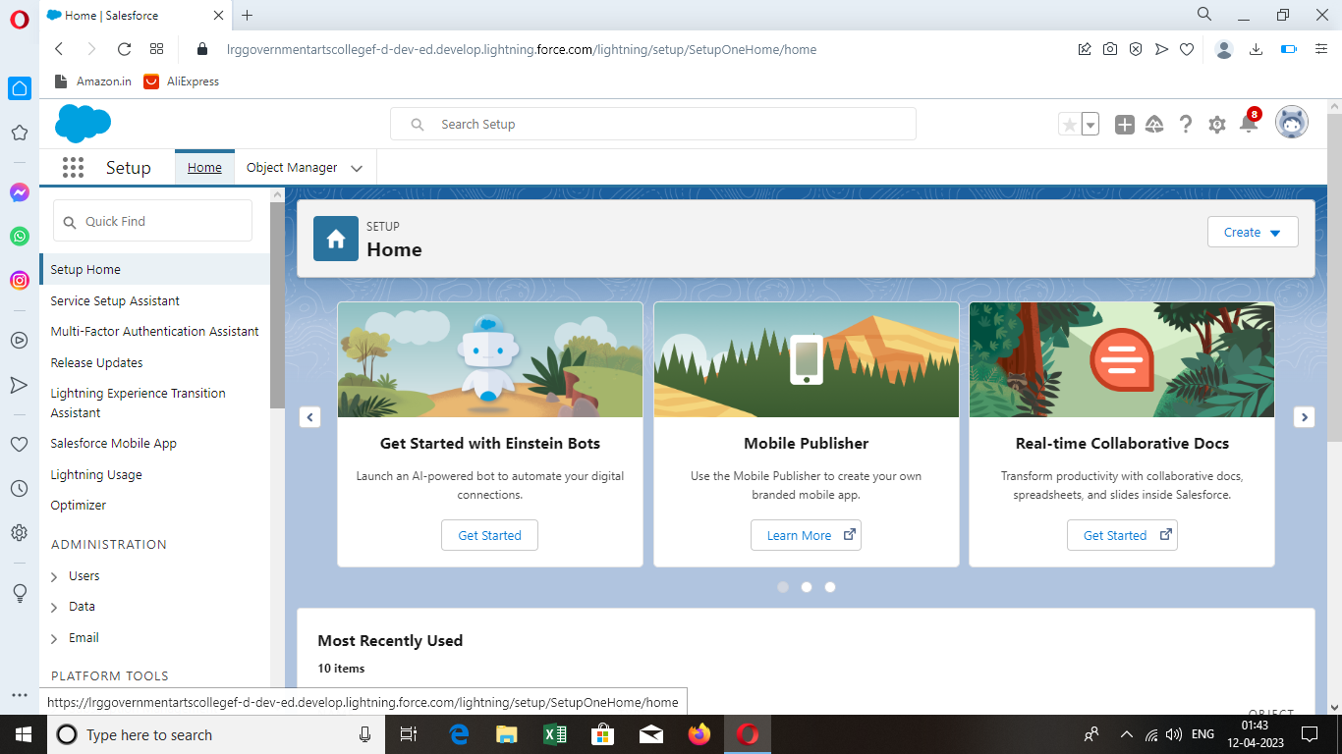

OBJECT:

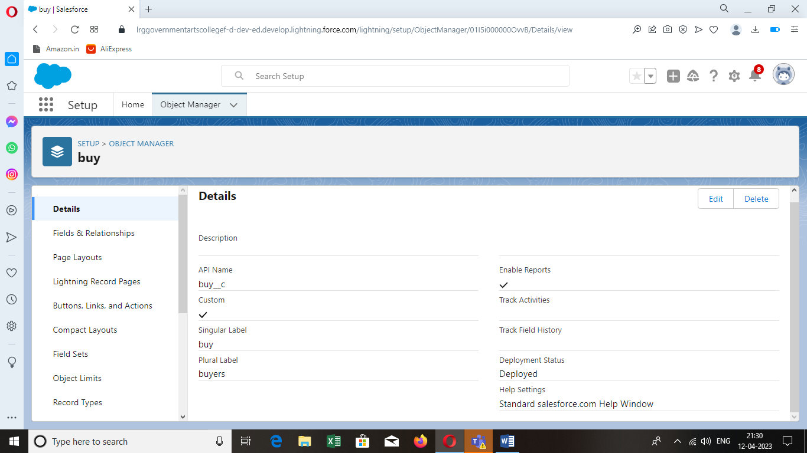

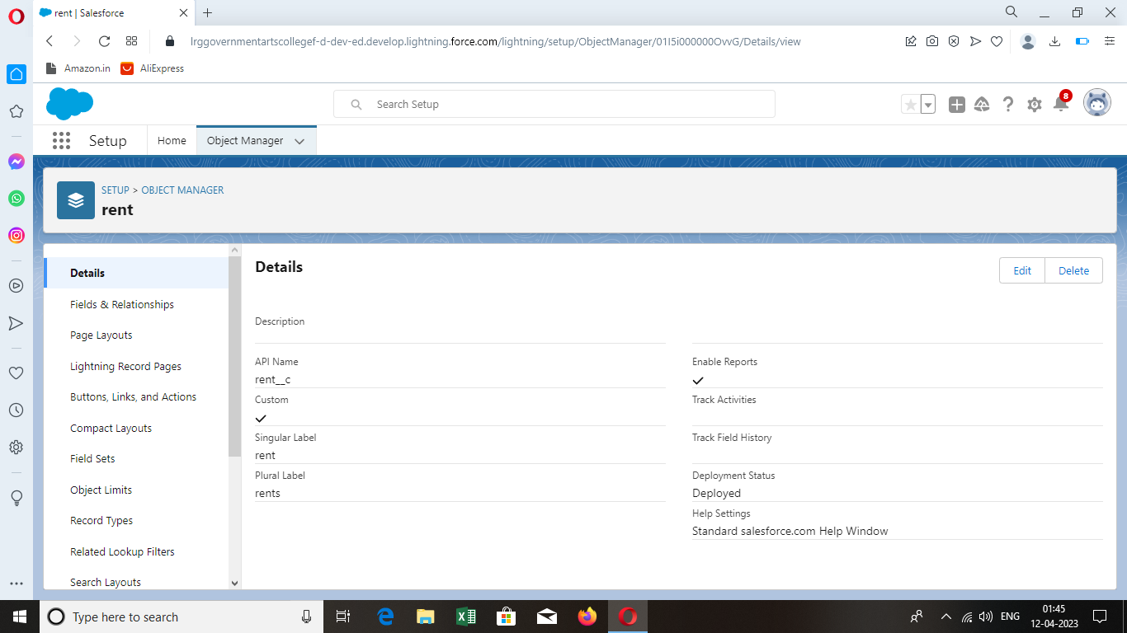

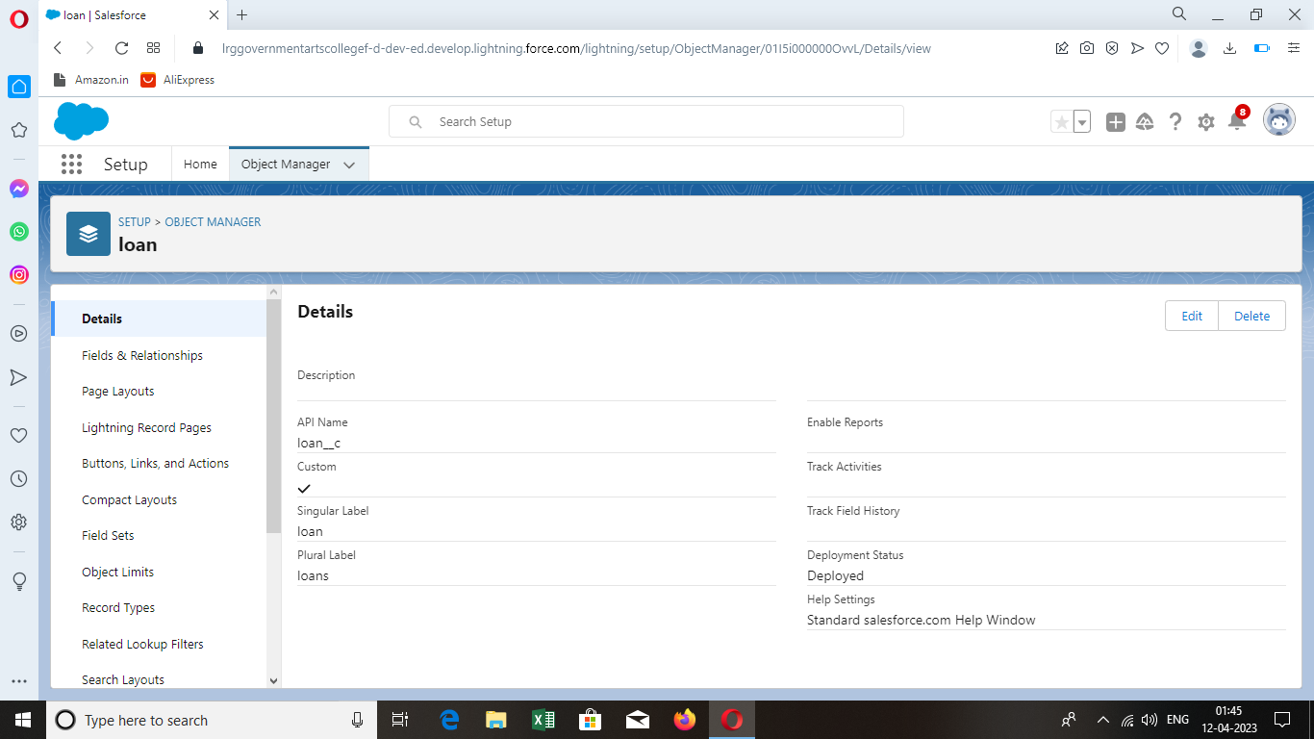

TABS:

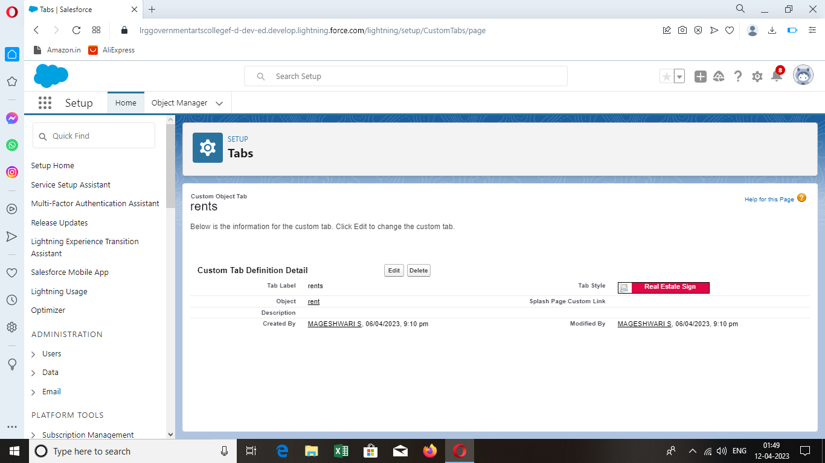

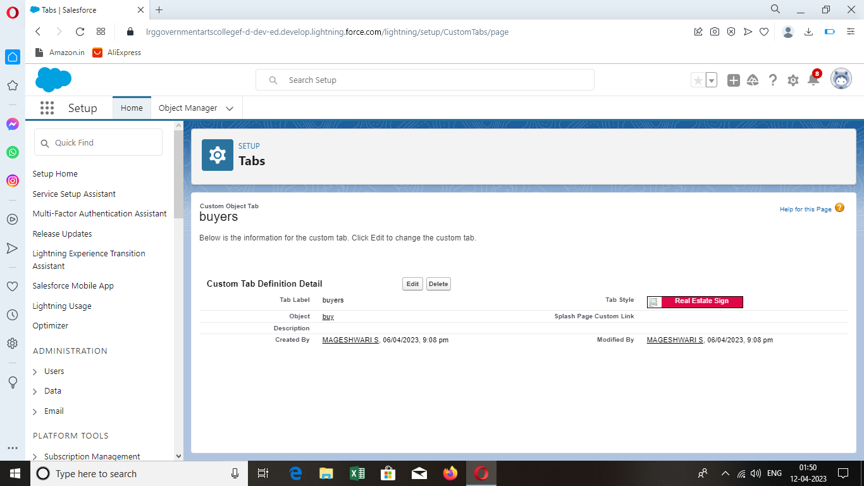

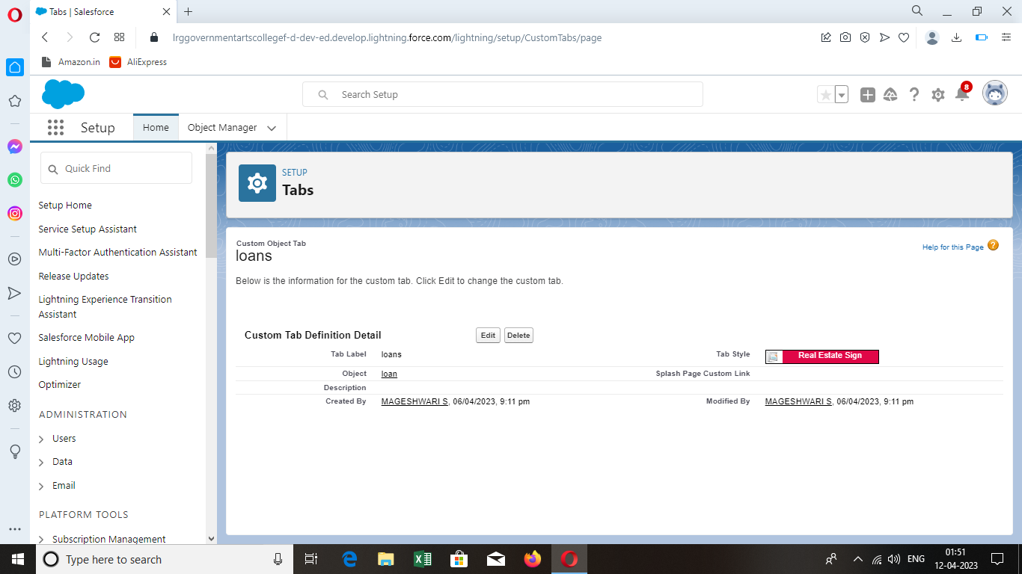

LIGHTNING APP:

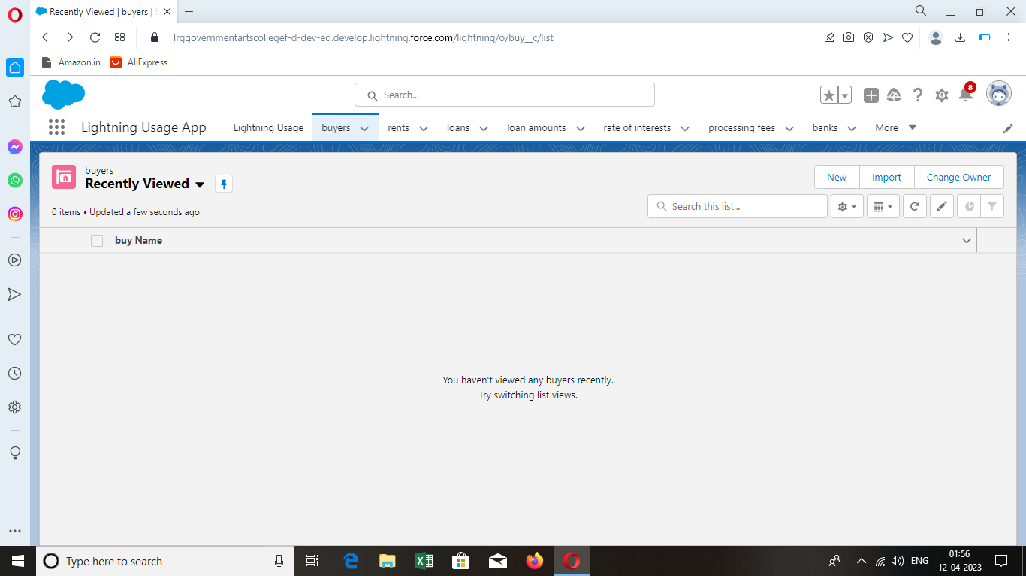

FIELDS:

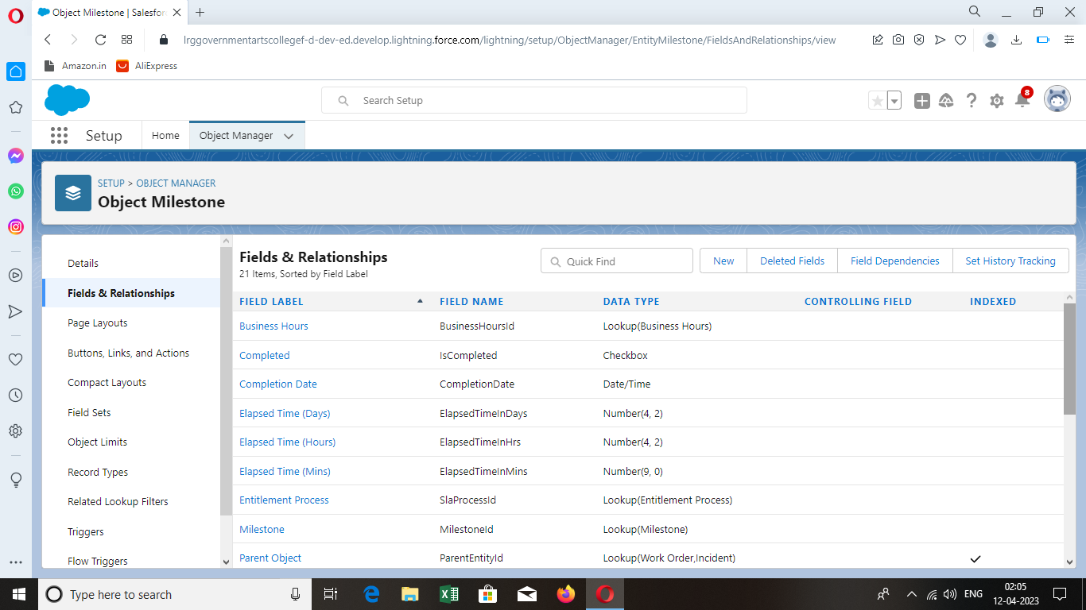

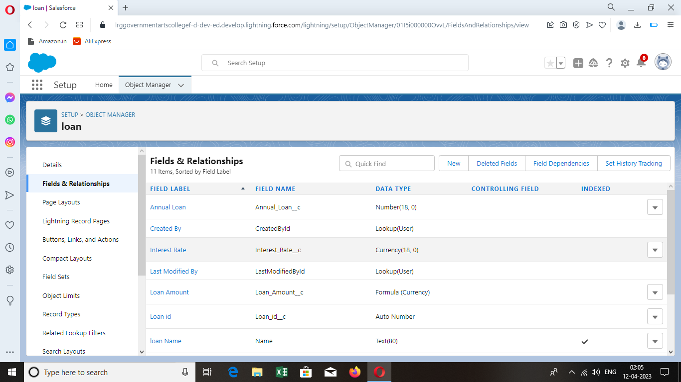

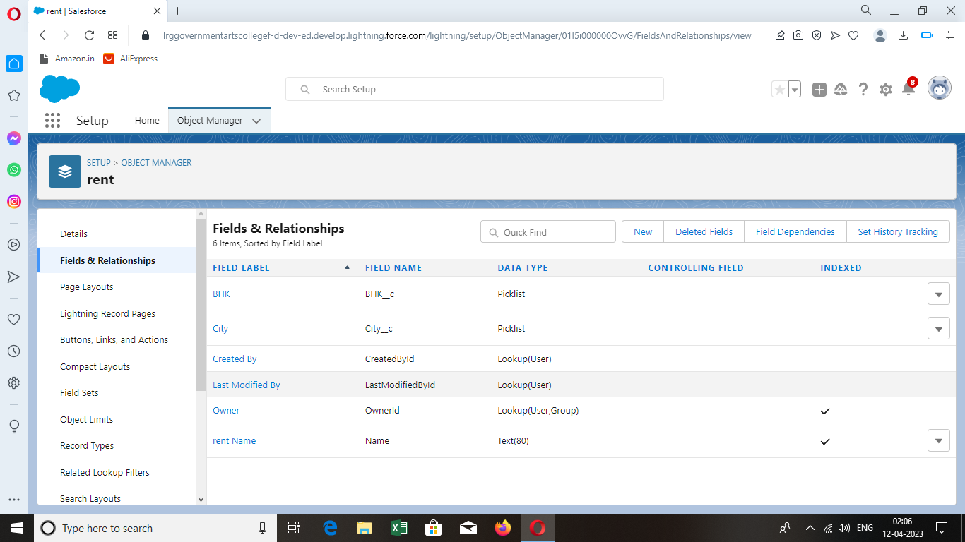

PROFILES:

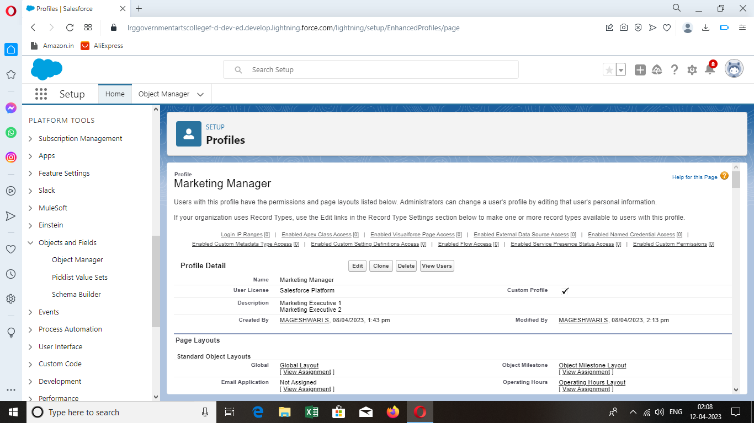

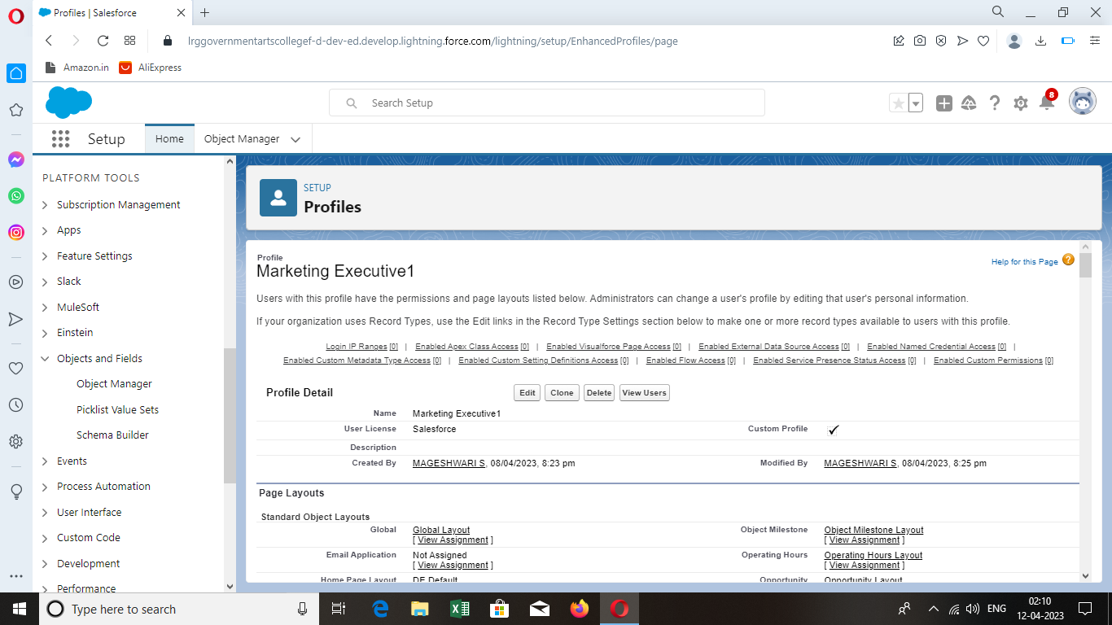

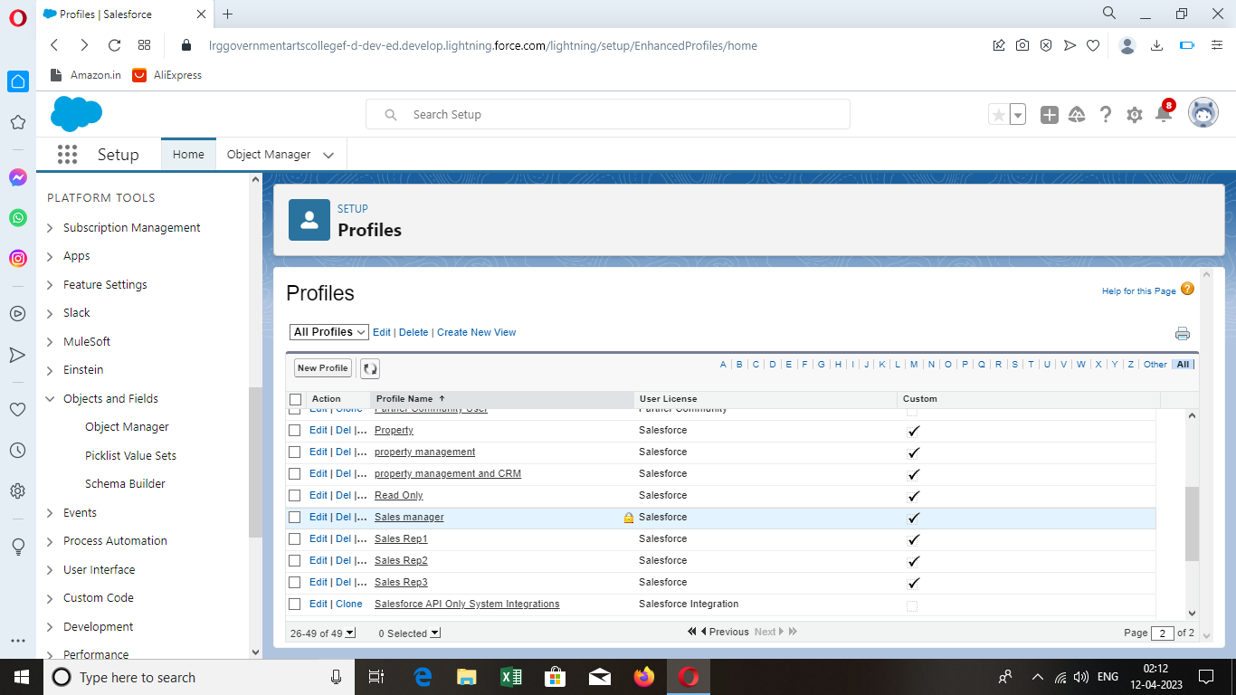

NEW USERS:

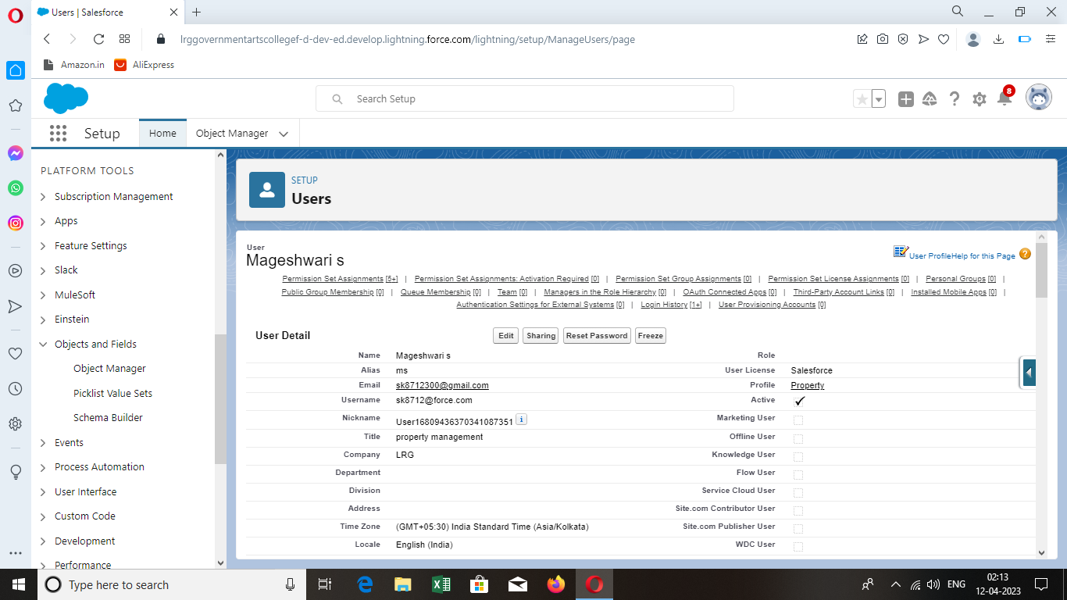

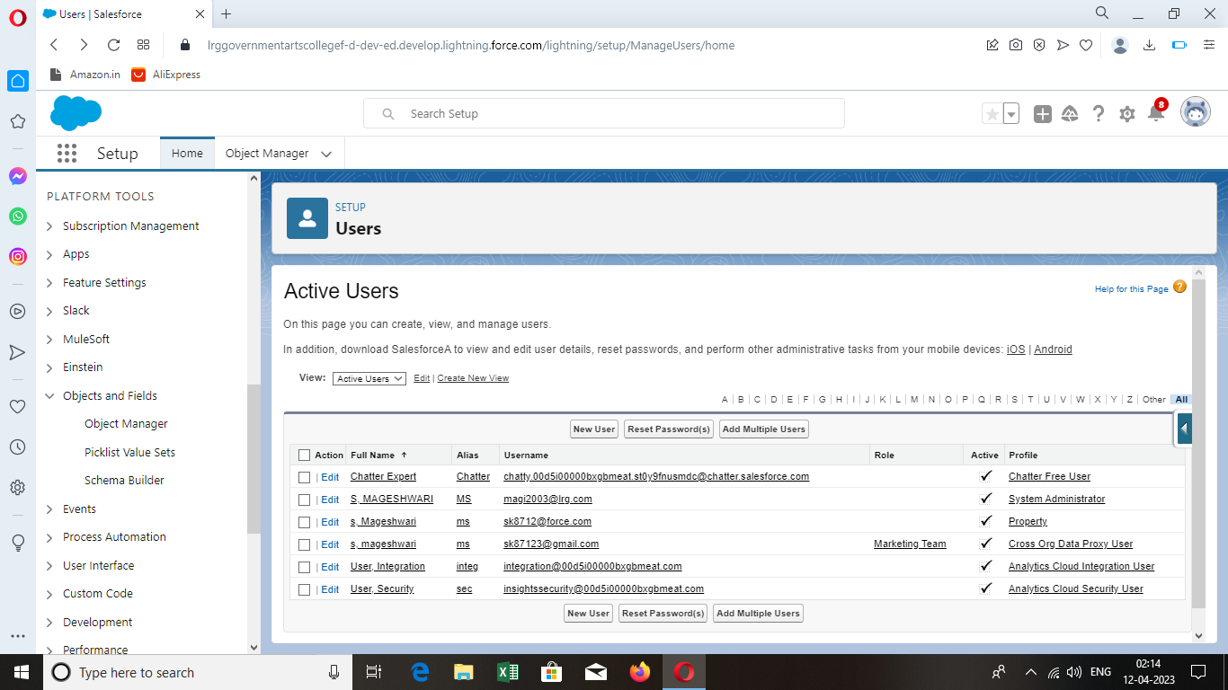

PERMISSION SETS:

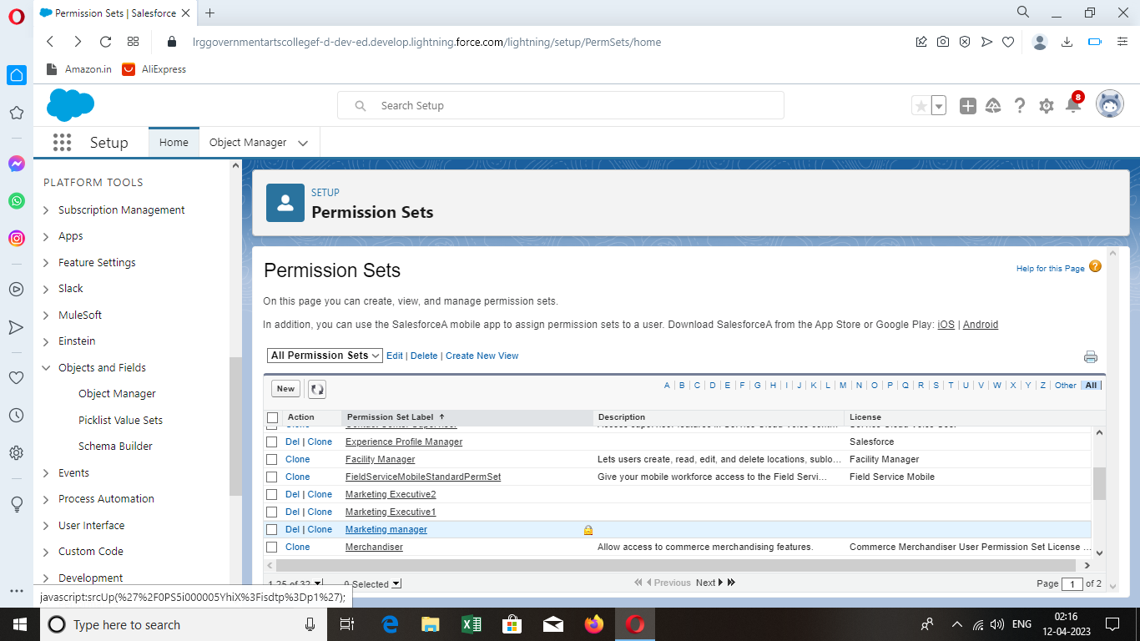

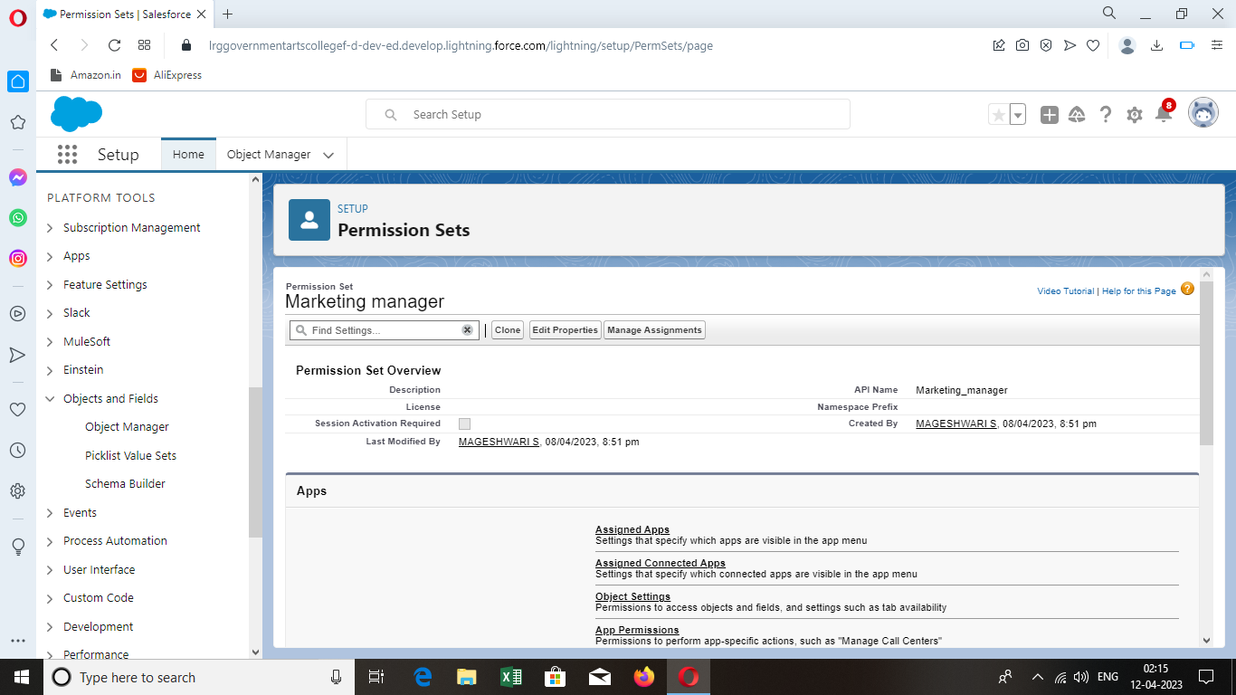

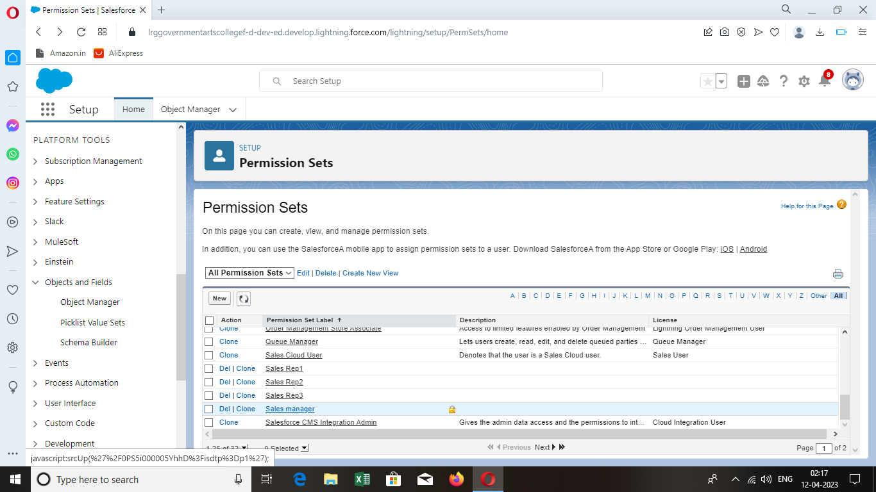

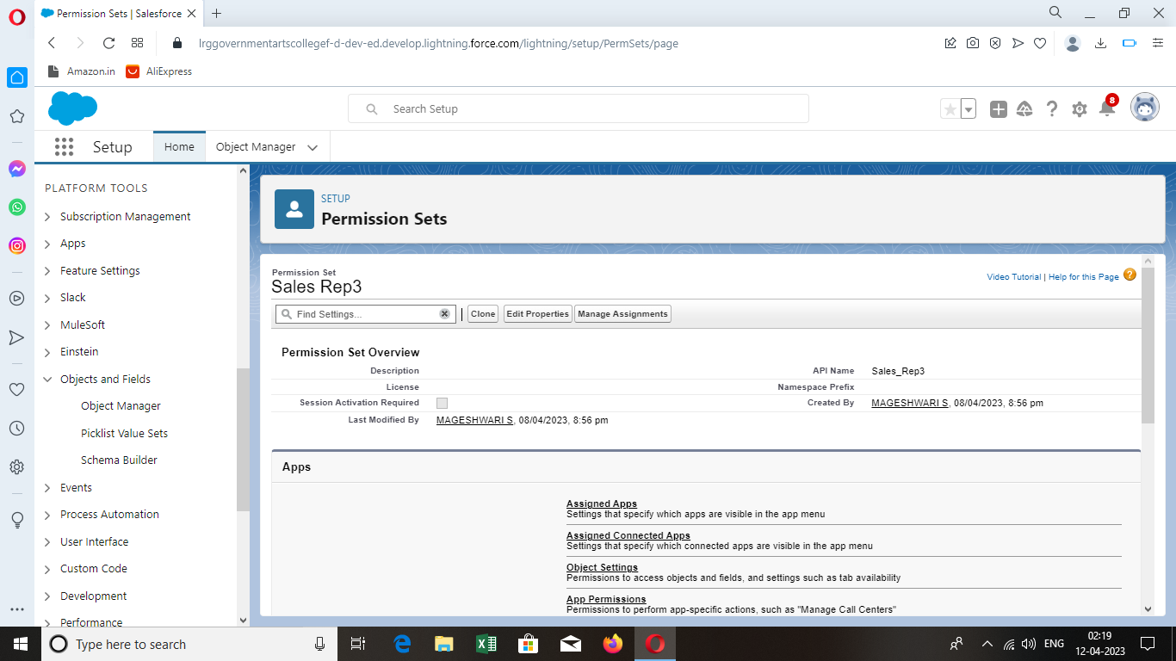

SETUP FOR OWD:

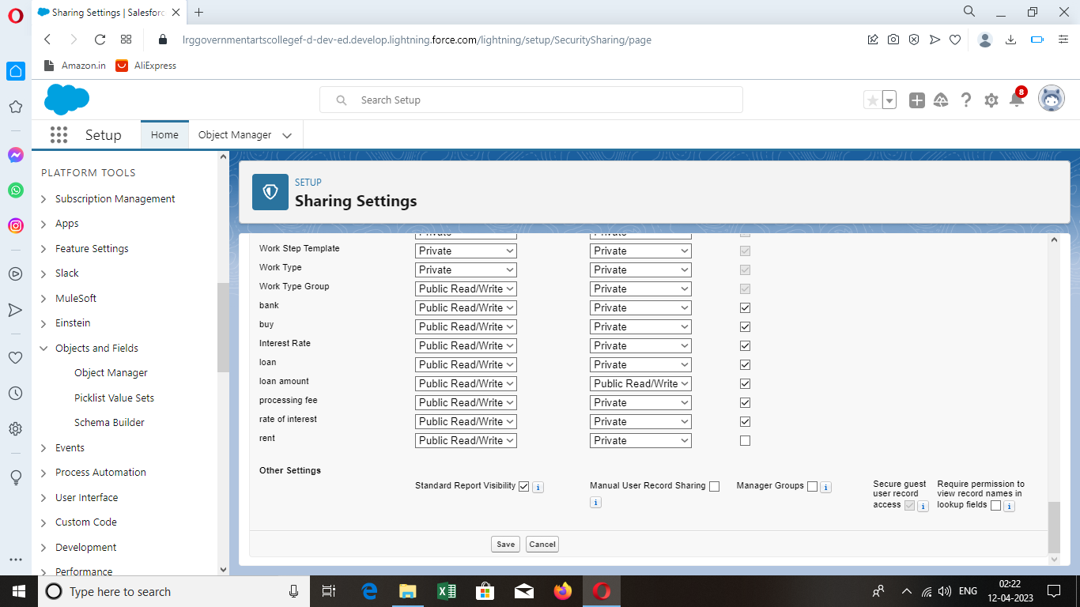

REPORT:

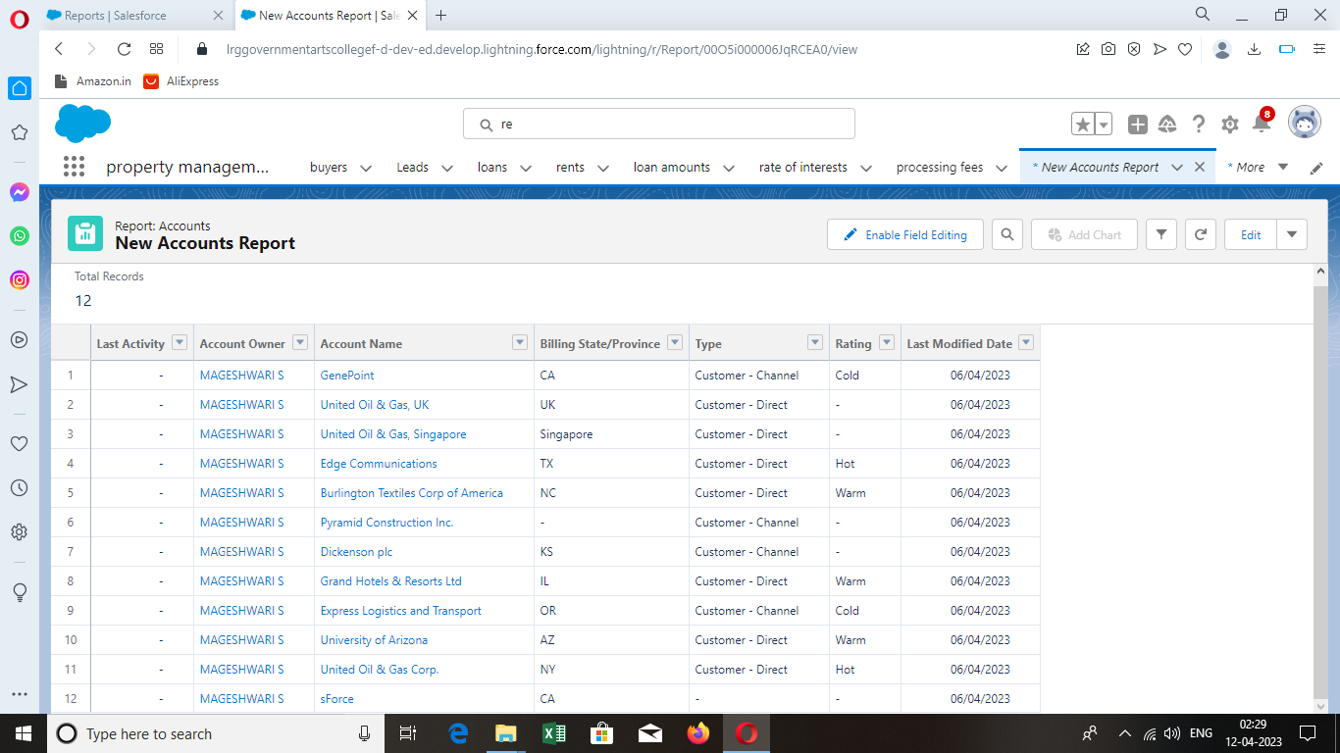

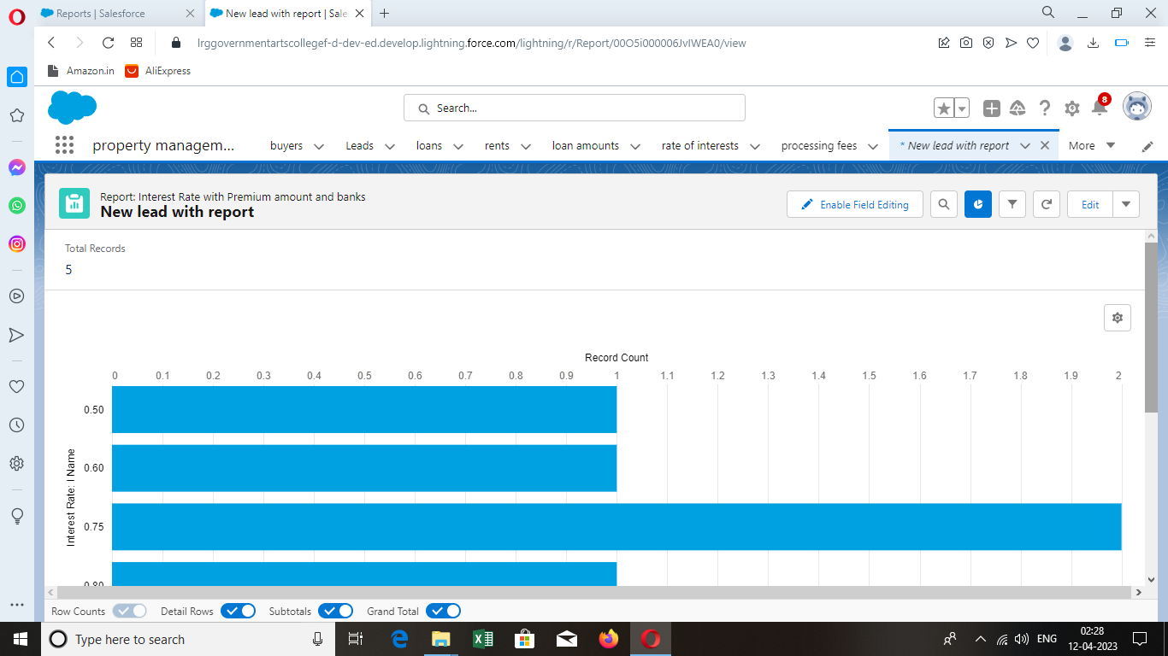

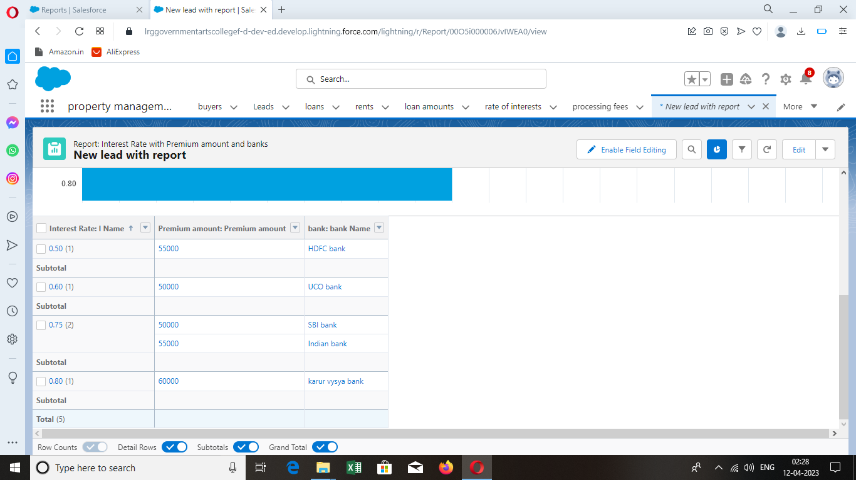

DASHBOARD:

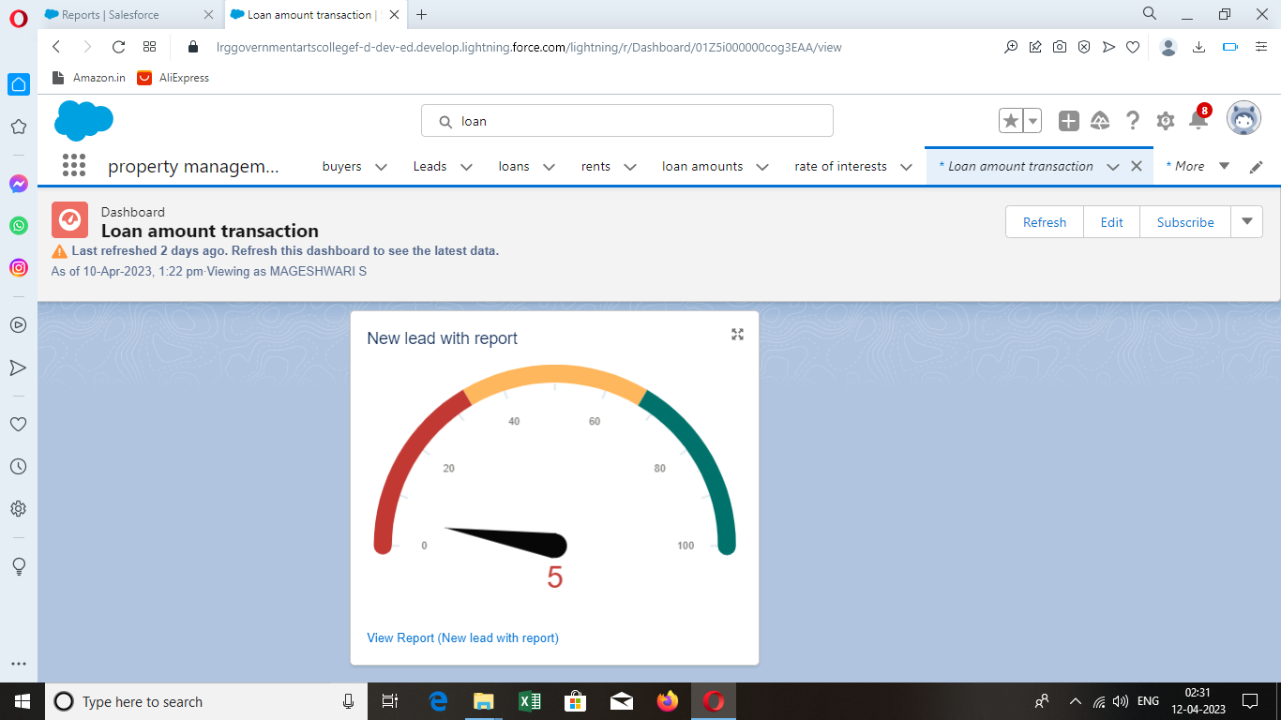

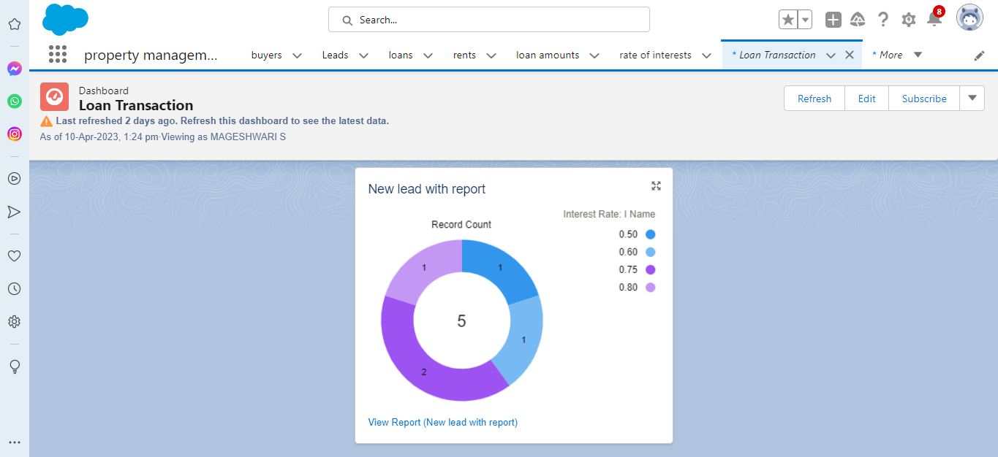

1. Trailhead Profile Public URL:

Team Lead(Mageshwari S)-https://trailblazer.me/id/mages64

Member 1(Babyshalini R)-https://trailblazer.me/id/sbaby2927

Member 2(Kaviya M)-https://trailblazer.me/id/kmatchendran

Member 3(Kumarathal K)-https://trailblazer.me/id/hbharathi2

1. (i)Advantages:

* Centralized Data Management
* Streamlined Processes
* Better Tenant Management
* Improved Financial Management
* Mobile Access

(ii)Disadvantages

* Cost
* Complexity
* Integration
* Dependence On Salesforce

1. Application

The application of salesforce is vast and an provide numerous benefits to real estate companies. Salesforce can be used to automate various property management processes, including lease management , rent collection ,improve efficiency , reduce error, save time and money .

Salesforce can be integrated with other software or system, such as accounting software or property management software.This can be help property managers streamline their operations and improve efficiency.

Salesforce may integrating data from sensors and other IOT devices to provide real-time insights into property performance and improve maintenance and management processes.

1. Conclusion

This app is all about the field study that we have conducted on our real estate management systems to login insight into users of the product that we design.By having these top five features as the foundation of a mission critical system addressing the demands and challenges of the real estate industry,upward trend will continue,growth will be realized,and success will be inevitable.

1. Future Scope:

The application and future scope of property management using salesforce are vast, and the platform has the potential to transform the way real estate companies manage their properties.